Writing Annotated Bibliographies
An annotated bibliography is a list of citations to books, articles, websites and other sources that are collected for a research project. Each citation is followed by a brief descriptive and evaluative paragraph: the annotation. The purpose of the annotation is to inform the readers of the relevance, accuracy, and quality of the sources cited.

Sample annotated bibliography:
Lamott, Anne. Bird by Bird: Some Instructions on Writing and Life. New York: Anchor Books, 1995. Print.

Lamott's book offers honest advice on the nature of a writing life, complete with its insecurities and failures. Taking a humorous approach to the realities of being a writer, the chapters in Lamott's book are wry and anecdotal and offer advice on everything from plot development to jealousy, from perfectionism to struggling with one's own internal critic. In the process, Lamott includes writing exercises designed to be both productive and fun.

Lamott offers sane advice for those struggling with the anxieties of writing, but her main project seems to be offering the reader a reality check regarding writing, publishing, and struggling with one's own imperfect humanity in the process. Rather than a practical handbook to producing and/or publishing, this text is indispensable because of its honest perspective, its down-to-earth humor, and its encouraging approach.

Chapters in this text could easily be included in the curriculum for a writing class. Several of the chapters in Part 1 address the writing process and would serve to generate discussion on students' own drafting and revising processes. Some of the writing exercises would also be appropriate for generating classroom writing exercises. Students should find Lamott's style both engaging and enjoyable.

Source: Purdue OWL
Refer to pages 268-269 in your S&S Handbook for additional samples of annotated bibliographies.
Annotated Bibliography Instructions
Find ten (10) different sources (including at least five articles from the SCC Library databases) related to your topic. Cite them correctly in alphabetical order using MLA documentation (see Ch. 25 in your S&S Handbook) and write a brief paragraph for each source in which you summarize and evaluate the usefulness of the source for your research project.
You may choose to use a bibliography generator like BibMe to assist you in creating your annotated bibliography. You can access BibMe for free at www.BibMe.org/MLA
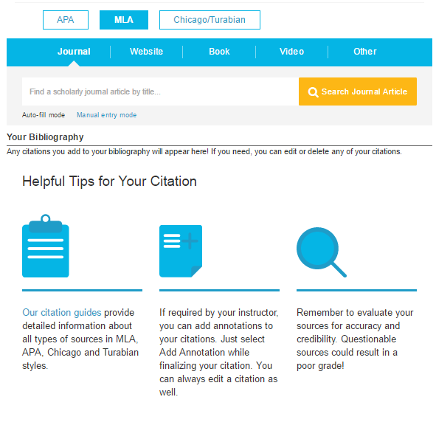
*Remember, your completed annotated bibliography must include citation information and a brief paragraph for at least ten (10) reputable sources. See Canvas for submission instructions and the due date for your completed annotated bibliography.

