SALEM COMMUNITY COLLEGE

SYLLABI

Spring 2016

Course Title: | WESTERN CIVILIZATION II
Course Code: | HIS 102
Lecture Hours: | 3
Lab Hours: | 0
Credits: | 3
Instructor: | DR. ROBERT REIGER
E-mail: | rreiger@salemcc.edu

Course Description:
Students will be introduced to the political, social, cultural, and economic history that shaped Western Society from 1600 to present. Students will engage the major debates and issues during this period, and they will be introduced to the historian’s craft.

Prerequisite: ENG 098

Co-requisite: none

Place in College Curriculum:
Western Civilization II functions as a required course in the Liberal Arts and Social Science /Political Science Programs. It also serves as a primary social science elective and as an open elective.

Required Text(s):
Western Civilizations: Volume 2 by:
Judith Coffin and Robert Stacey and Joshua Cole and Carol Symes
ISBN: 978-0-9393483-0

Grading procedure and policies:
A = (94 - 100); A- (90-93); B+ = ( 87 – 89); B= (83 – 86); B- (80-82), C+= (77-79),
C (70-76) D= (60-69); F = below 60. FA = below 60.
Attendance: Students are expected to attend all scheduled classes. The instructor will explain the specific attendance policy for the class.
Assignment feedback and grading will be completed within a few days after posting.
Student Assessment:

Final grades will be determined by completion of class work, examinations, written assignments:
• Midterm/Final examination: 60 points;

Major assignments and/or Chapter outlines and analysis questions: 40 points each;

Short-term assignments: 10 points each;
Quizes: 10 points.
Please note: After three unexcused absences from class, the final grade will be reduced by one letter grade.

Academic Honesty Policy:
Students found to have committed an act of academic dishonesty may be subjectto failure in this course, academic probation, and/or suspension from the college. See the Student Handbook for additional details.

COURSE CONTENT OUTLINE:

I. Orientation
a. Principles and methodology
b. Historiography
c. Orientation to Western Civilization
d. Orientation to the Course
II. The Age of Absolutism
a. What is Absolutism
b. Alternatives to Absolutism
c. A Commercial Revolution
d. Global Trade and Colonies

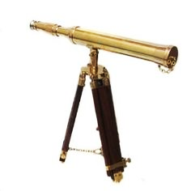
III. The Scientific Revolution
a. The Origins of the Scientific Revolution
b. Scientific Methods
c. Isaac Newton’s World
d. Was the Scientific Revolution Revolutionary?

IV. The Enlightenment
a. The Origins of the Enlightenment
b. The Philosophes
c. Gender, Race, and the Enlightenment
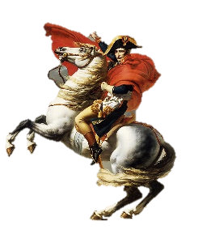
d. High and Low Culture
e. Is the Enlightenment Still Relevant?

V. The French Revolution
a. The Origins of the French Revolution
b. The Four Stages of Revolt
c. The Rise of Napoleon
d. The Fall of Napoleon and the Consequences of Revolt
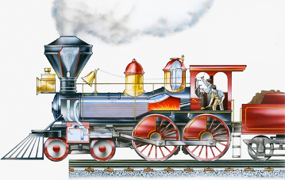
VI. The Industrial Revolution
a. The Origins of the Industrial Revolution
b. The Industrial Revolution on the Continent
c. The Social Consequences
d. The Consequences of the Industrial Revolution
VII. The Age of Ideologies
a. The Restoring Order
b. New Ideologies
c. Culture Shock
d. The End of Restoration
e. The Impact of Ideologies on Modern Society

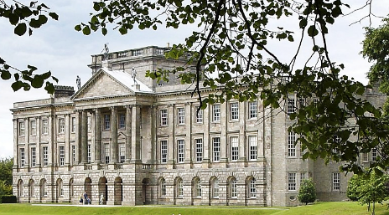
VIII. Creating a Nation-State
a. The Origins of 1848
b. Building a Nation-State
c. The Crimean War
d. Realism and Cultural Movements
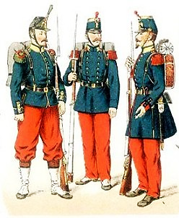
IX. Imperialism and Colonialism
a. Why Imperialism?
b. China and India
c. The French Imperial Effort
d. The Scramble for Africa
e. Imperial Culture
X. The Second Industrial Revolution
a. New Technologies
b. Globalism
c. Labor Movements
d. Women’s Movement
e. Culture and Society

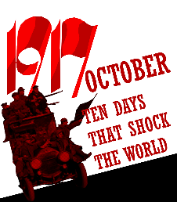
XI. The Great War
a. The Origins of War
b. War
c. Empires at War
d. The Russian Revolution
e. The War Ends

XII. In Between
a. The Soviet Union
b. Fascism
c. The Rise of Nazi Germany
d. Culture and Society
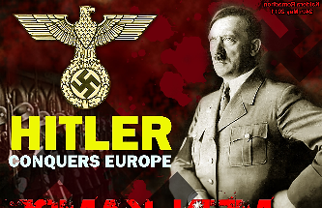
XIII. The Second World War
a. The Causes
b. Hitler and Europe
c. Two Front War
d. The Holocaust
e. The Home Front
f. The A-Bomb
g. The Consequences of War
XIV. The Cold War
a. Stalin and West
b. Economic Recovery
c. Anti-Colonialism
d. Society and Culture
e. The Soviet Union Collapses
XV. The Modern West
a. Globalization
b. Oil Politics
c. Conflict and Terrorism
d. Where Do We Go From Here?

COURSE PERFORMANCE OBJECTIVES

Course Performance Objectives I:
Students will have a knowledge and understanding of the causes of major historical events and evaluate their impact on Western society.

Learning Outcomes; the student will:
- Define the causes and consequences of several major events
- Synthesize competing interpretations of the causes and consequences of major historical events

Course Performance Objectives II:
Students will be capable of recognizing the difference between primary and secondary sources, and will be able to analyze primary sources within their historical context.

Learning Outcomes; the student will:
- Recognize primary and secondary sources
- Evaluate the positives and negatives of primary and secondary sources, including bias
- Use primary and secondary sources to develop an argument of their own

Course Performance Objectives III:
Students will be aware of how historiographical trends are shaped by their generation, background, and perspective.

Learning Outcomes; the student will:
- Identify major historiographical trends in Western Civilization
- Compare and evaluate various historiographical schools of thought
- Discuss the reasons why certain trends appear during certain periods in history
- Discuss the issue of subjectivity and objectivity in history

Course Performance Objectives IV:
Students will be able to construct a thesis/argument in writing and/or orally, which is informed by the readings in the course and/or outside research.

Learning Outcomes; the student will:
- Write a thesis-driven paper(s) on a topic relevant to Western Civilization
- Defend a certain position, either orally or written, on a topic related to Western Civilization
- Justify the importance of a historical person, invention, or a social, political, and/or cultural movement

Course Performance Objectives V:
Students will be acquainted with the transformation of Western cultural, political, and social movements and draw links to modern society.

Learning Outcomes; the student will:
- Explain the transformation of Western cultural, political, and social movements, focusing on continuity and change
- Summarize the contributions of political, economic, and social ideologies to modern society

Course Performance Objectives VI:
Students will be capable of identifying various aspects of Western historical geography.

Learning Outcomes; the student will:
- Label major political and social units of organization
- Discuss how geography and geology shaped Western development

GENERAL EDUCATION REQUIREMENTS:
The general education goals covered in HIS101 are written and oral communication, historical perspective, information literacy, and global and cultural awareness.

OUTCOMES ASSESSMENT:
A college-wide assessment program has been put into place to enhance the quality and effectiveness of the curriculum and programs at Salem Community College. As part of this assessment program, the learning objectives for this course will be assessed. Assessment methods may include tests, quizzes, papers, reports and other instruments. Copies of all assessments are available in an electronic assessment bank maintained by the Institutional Research and Planning Office.
COURSE ACTIVITIES:
Students may engage in a variety of activities including lectures (PowerPoint or traditional), discussion, debates, oral and written presentations, video and/or internet presentations, and exams.

COURSE REQUIREMENTS AND MEANS OF EVALUATION:
The instructor will evaluate the students in various ways. Exams, quizzes, papers, oral presentations, and class participation may be used to evaluate students. Please refer to the instructor’s syllabus addendum (to be distributed in class) for specific information regarding the specific course requirements and means of evaluation.

ATTENDANCE POLICY:
Regular and prompt attendance in all classes is expected of students. Students absent from class for any reason are responsible for making up any missed work. Faculty members establish an attendance policy for each course and it is the student’s responsibility to honor and comply with that policy.

ACADEMIC HONESTY POLICY:
Students found to have committed an act of academic dishonesty may be subject to failure of this course, academic probation, and / or suspension from the college.
See the Student Handbook for additional details.

ADA STATEMENT:
If you have a 504 Accommodation Plan, please discuss it with your instructor.
If you have any disability but have not documented it with the Disability Support coordinator at Salem Community college, you must do so to be eligible for accommodations. To contact the Disability Support Coordinator, call 856-351-2773,
or email disabilitysupport@salemcc.edu to set up an appointment. To find out more information about disability support services at Salem Community College, visit www.salemcc.edu/students/student-success-programs/disability-support.

